Internship Feedback Form
Employer Feedback for Internee Students
BACHELORS IN ______________________
Student Name:
Seat No:
________________________________________________________________________
___________________________________ Batch: ______________________________
Organization/ Industry: ____________________________________________________________________
Department:
Focal Person
________________________________________________________________________
Name: _____________________________ Designation: ________________________
Cell#: _____________________________ Email:
from _____________________________ to
________________________
________________________
Internship dates:
Internship hours per week: _____________________________
S. No.
Questions
1
2
3
4
5
Relevant technical knowledge relevant essential to do his/her
assignments.
1.
2.
Ability to identify, analyze and research literature for assigned
problems.
Ability to exhibit awareness of societal, health, safety, legal and
cultural responsibilities relevant to the field.
Ability to exhibit ethical growth and professionalism.
3.
4.
5.
Ability to complete assignments, meet deadlines, understand
instructions and work with others.
Oral and written communications skills of the internee.
6.
1
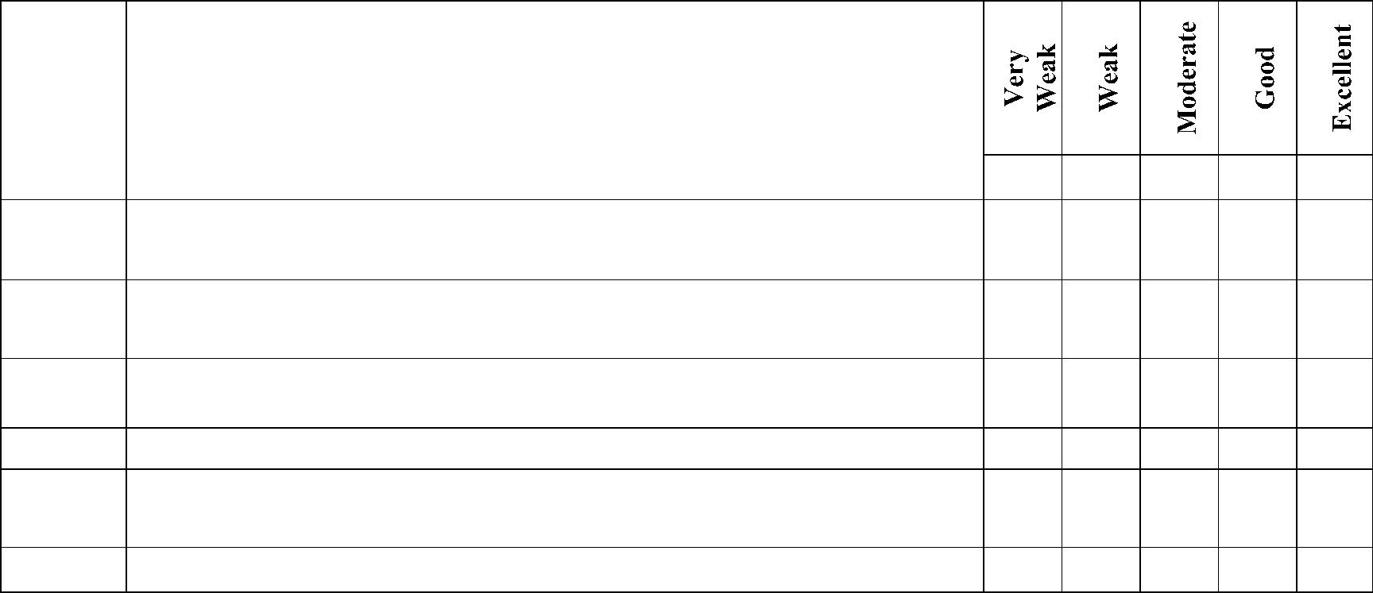


The questions below are tied to the Program Learning Outcomes of Bachelor in _________________.
Response to these questions is mandatory. Evaluate the internee, by placing a tick in the box that confirms most to your views.
The Directorate of Industrial Liaison requests your opinion on questions that are relevant to our internee students in an effort to continually improve our program in department of ________ ____________________________. You may also visit the departmental website at https://www.neduet.edu.pk/faculties_and_departments for more details.
F/SOP/DIL 01/10/04

Response to the following questions is optional.
Please provide detailed job description for the internee:
Please provide a pen picture of your experience with the internee:
Any other comments:
Signature and Stamp of the Employer: ______________________________

Department of ______________________________, NED University of Engineering & Technology Karachi,
would like to thank you for your willingness in spending time to complete this questionnaire.
All these input and suggestion will be used to perform the process of "Continuous Quality Improvement" (CQI) for our undergraduate programs to ensure the programs meet the current market needs.
Please email the completed form to dil@neduet.edu.pk or post it to the following address:
Directorate of Industrial Liaison
NED University of Engineering and Technology
Main Campus, University Road
Karachi – 75270
Pakistan
2


F/SOP/DIL 01/10/04

