INDUSTRIAL VISIT FEEDBACK FORM
Dear Customer,
To monitor and to improve the services provided by Directorate of Industrial Liaison (DIL) your feedback is
extremely important for us. You are kindly requested to fill-up this form and return to DIL immediately after
conclusion of your visit.
To be filled by the person(s) visiting the industry.
Please tick ( √ )appropriate boxes.
A) Are you:
i) Faculty
ii) Student
iii) Other(s)
Please specify: _______________________________________
B) Name of the organization visited: _______________________________
C) Date of Visit/ Time:____________________________________________
D) Brief purpose of the visit:
i) Observation/ Study visit
ii) Project related visit
iii) Other(s)
Please specify: _______________________________________
_{E) P}lease check the appropriate numeric boxes as per your perception of our services.
(Starting from 10 to 1)
Good
Average
Poor
10
9
8
7
6
5
4
3
2
1
1) The visit was relevant to your purpose/ study?
2) The duration of visit was appropriate and meet your requirements?
3) The DIL arranged your visit according to your requirement (time/
schedule)?
4) Your overall assessment about the performance of DIL office
arranging visits?
F) Please Check the appropriate box below:
1 The guidance/ assistance provided by visiting organization met
Yes
Yes
No
No
your requirements?
2 Do you require to visit the industry again ?
G) Additional Comments/ Suggestions for Improvement or Complaint:
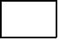
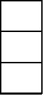
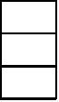
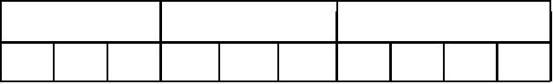
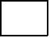

F/SOP/DIL 01/07/00

